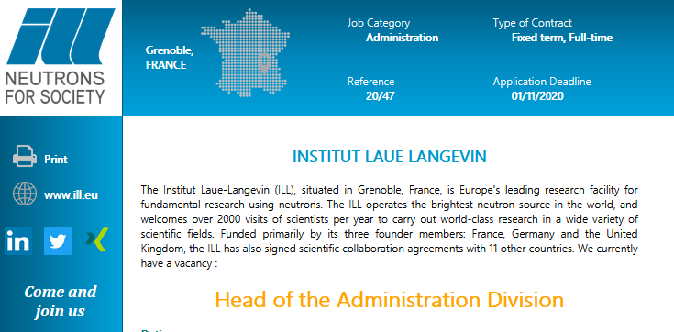

https://www.ill-recruits.eu/generator.php?id=1132

